
AN: ISO 9001: 2015 (QMS) & ISO 14001: 2015 (EMS), RoHS

MANUFACTURER OF:

Networking Racks, Server Racks, Outdoor Racks, Electrical Panels, Junction Box
Email: info@innoracks.in Website: www.innoracks.in
Phone No: 0129-2985686

WALL-MOUNT/POLE-MOUNT RACKS
Height Available | Width(in MM) | Depth Available  (in MM) | Description/ Specifications
2U  3U  4U  6U  9U  12U  15U | 550MM & Internal- 19INCHES | 350  400  500  600  650 | Application | Network Switches/Routers/Firewall/ DVR/NVR/Audio- Visual Equipment/Low Depth Servers & other 19” Electronic
2U  3U  4U  6U  9U  12U  15U | 550MM & Internal- 19INCHES | 350  400  500  600  650 | Material | CRCA Steel Single Wall
2U  3U  4U  6U  9U  12U  15U | 550MM & Internal- 19INCHES | 350  400  500  600  650 | Front Door | Glass (Toughened Glass 4mm) /Metal Door with Key Lock
2U  3U  4U  6U  9U  12U  15U | 550MM & Internal- 19INCHES | 350  400  500  600  650 | Mounting Channels | 2 Pair Heavy Duty (1.2mm)
2U  3U  4U  6U  9U  12U  15U | 550MM & Internal- 19INCHES | 350  400  500  600  650 | Cooling Option | 1-2 fan Provision mounted on Top Panel
2U  3U  4U  6U  9U  12U  15U | 550MM & Internal- 19INCHES | 350  400  500  600  650 | Load Bearing Capacity | Up to 30 -40 KG
2U  3U  4U  6U  9U  12U  15U | 550MM & Internal- 19INCHES | 350  400  500  600  650 | Construction | Dismantle/Welded Construction Overall 0.8mm Thickness, Load Bearing angles are 0.8 MM
2U  3U  4U  6U  9U  12U  15U | 550MM & Internal- 19INCHES | 350  400  500  600  650 | Side Panels | Integrated side panels with perforation

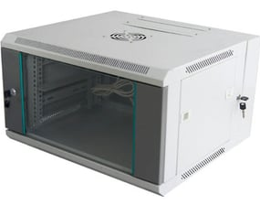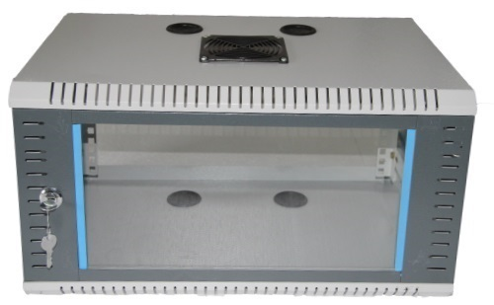

NETWORK RACKS
Height Available | Width  (in MM) | Depth Available  (in MM) | Description/ Specifications
18U  24U  27U  32U  36U  42U  (Can be customized) | 600MM  800MM | 800MM  1000MM | Application | Network Switches/Routers/Firewall/ DVR/NVR/Audio- Visual Equipment/Low Depth Servers & other 19” Electronic
18U  24U  27U  32U  36U  42U  (Can be customized) | 600MM  800MM | 800MM  1000MM | Material | CRCA
18U  24U  27U  32U  36U  42U  (Can be customized) | 600MM  800MM | 800MM  1000MM | Front Door | Glass (Toughened Glass 4mm) /Metal Door with Key Lock
18U  24U  27U  32U  36U  42U  (Can be customized) | 600MM  800MM | 800MM  1000MM | Mounting Channels | 2-4 Pair Heavy Duty (2.0mm)
18U  24U  27U  32U  36U  42U  (Can be customized) | 600MM  800MM | 800MM  1000MM | Cooling Option | 4 fan Provision mounted on Top Panel
18U  24U  27U  32U  36U  42U  (Can be customized) | 600MM  800MM | 800MM  1000MM | Load Bearing Capacity | Up to 600-1000 KG
18U  24U  27U  32U  36U  42U  (Can be customized) | 600MM  800MM | 800MM  1000MM | Construction | Front Glass & full Perforated Door option, Rear Steel Perforated Door,
18U  24U  27U  32U  36U  42U  (Can be customized) | 600MM  800MM | 800MM  1000MM | Side Panels | Detachable side panels with perforation

Standard Accessories:
- Cantilever tray/ Keyboard Tray/ Sliding Tray
- Fix Shelf/ Shelf Tray (Additional Equipment Shelf)
- Cooling Fan
- Power Distribution Unit (PDU)
- Equipment Mounting Hardware
- Cable Managers
- Castor Wheels
- Blank Panels

Features | Simplifications
Robustness | Modularity & flexibility of Innoracks cabinets enable to meet challenging rugged environments and harsh conditions found in outdoor or factory set-up.
Discernibility | Tempered glass on front door provides good visibility for observation of operating equipment.
Affirmative Dismantling | Easily removable front door for access
Commodious Cable Entry | Cable entry access options from top of cabinet

Other Features:
- Same model covering all U requirements.
- Capacity to load heavy equipment easily
- Allows maximum airflow inside the racks
- Facilitates comfortable & smooth server installation without any tool or support
- Helps IT engineers to install equipment without mismatch
- Enables external electrical grounding
- Accommodates small depth IT equipment
- Removes hot air inside racks and helps maintain the temperature
- Good expandability & upgradability
- Adjustable mounting depth
- Sturdy Construction, Excellent Finish
- Optimum Performance
- Beautiful Appearance
